Michael Weaver

CST – 221

John Zupan

1/21/2018

GitHub Link: <https://github.com/battousairurik/CST-221>

**UNIX Family of Operating Systems**

WHOAMI and USERS example

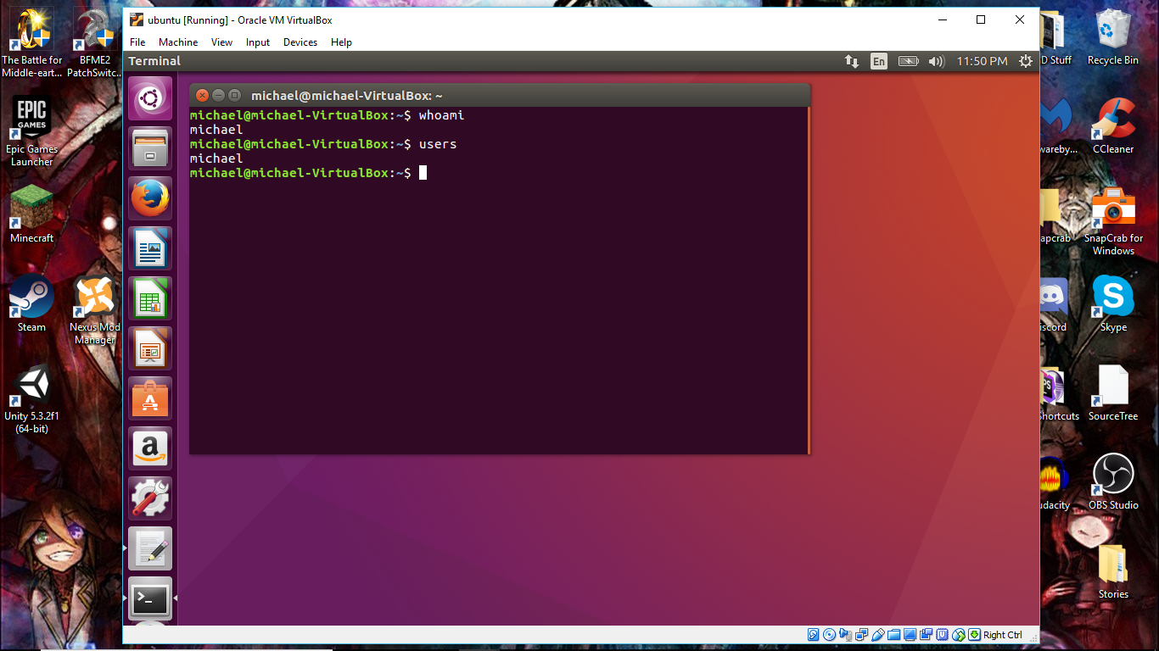

List and Directory exploration

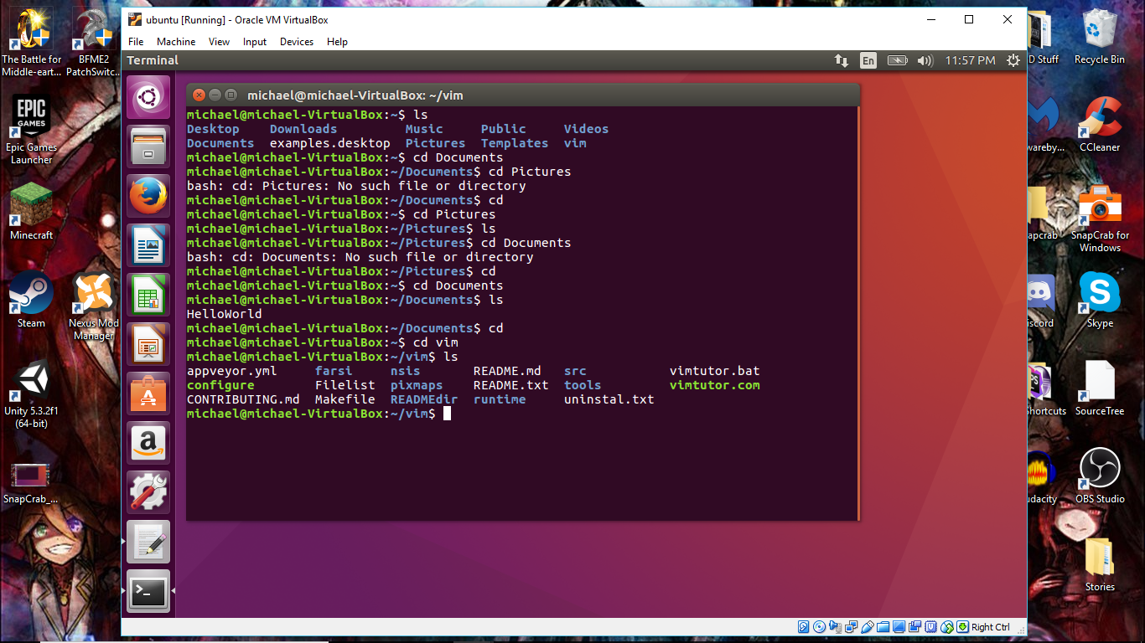

CHMOD example

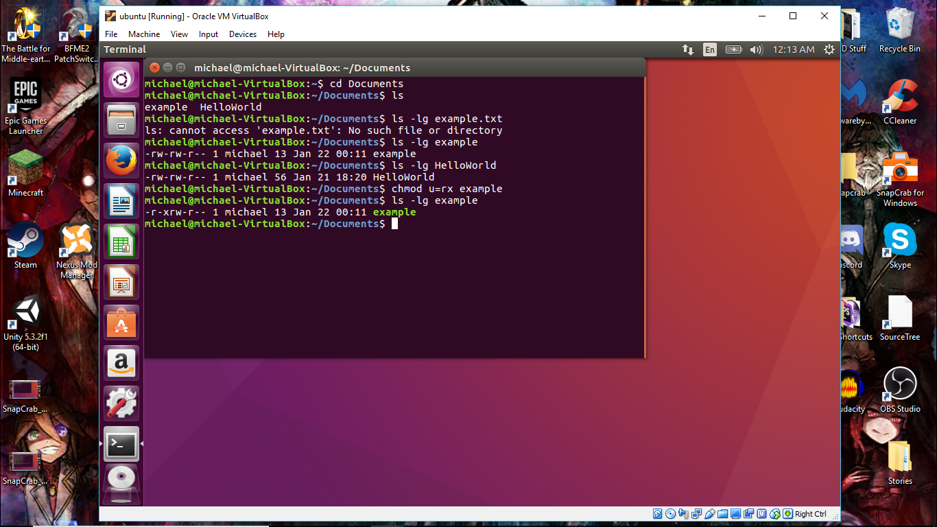

Environment Variables

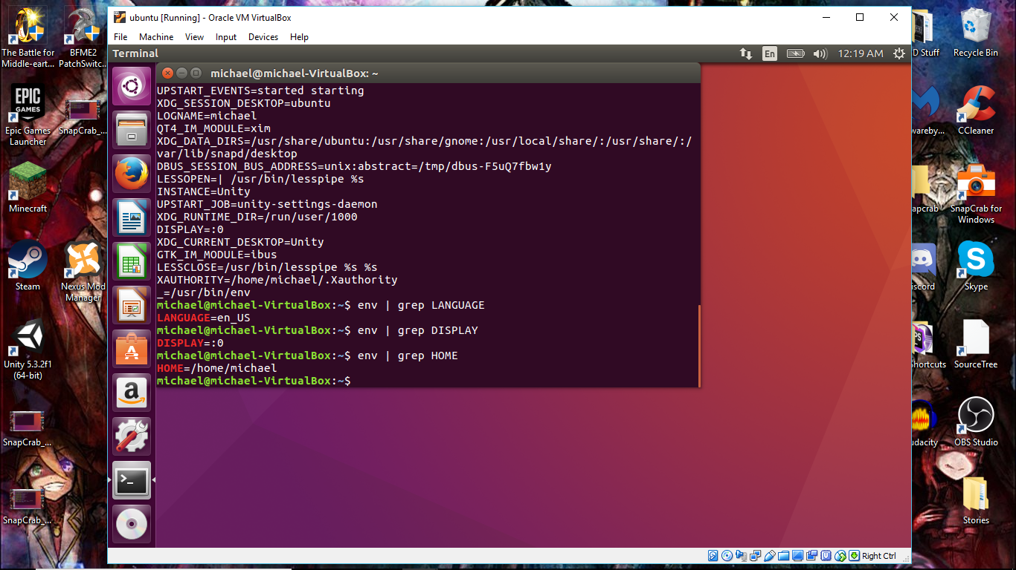

GREP

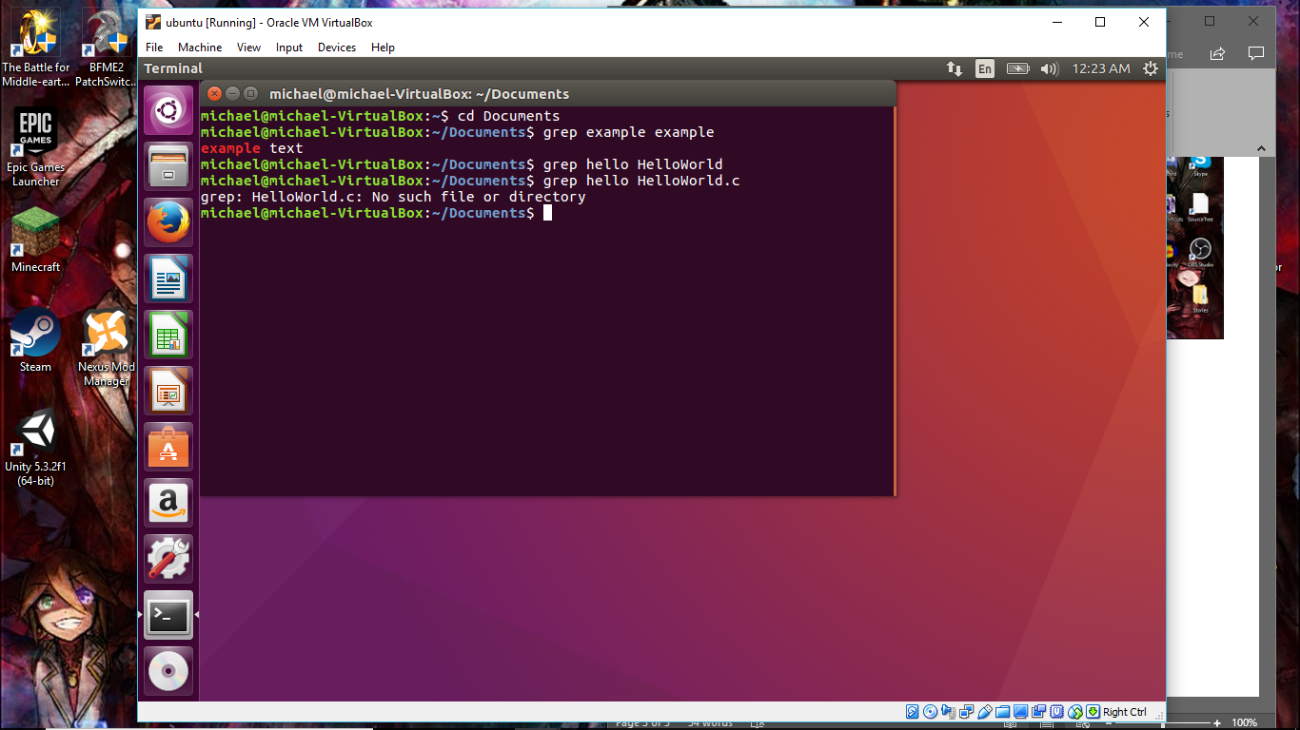

SORT / GREP / PIPING

…

SUPERUSER

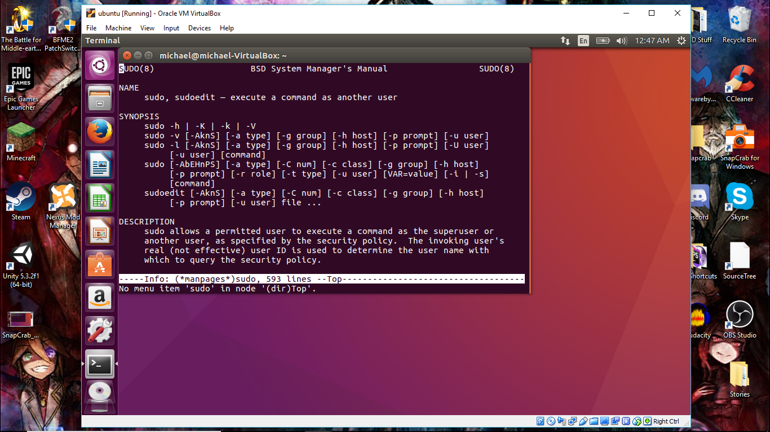

Invoking the superuser account grants you temporary access and privalages that you normally would not have access to. You can access files normally reserved for others users, change other user access, and do a variety of others administrative actions. In most cases you would use superuser when you wish to have unrestricted access to the machine.

Other Commands

MKDIR (create new folder) and CP (copy / paste)

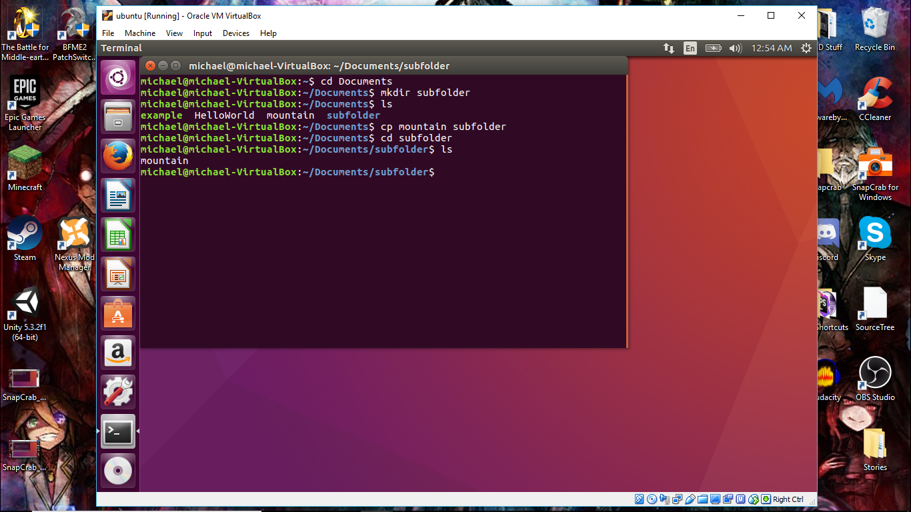

CAT / RM / and POWEROFF

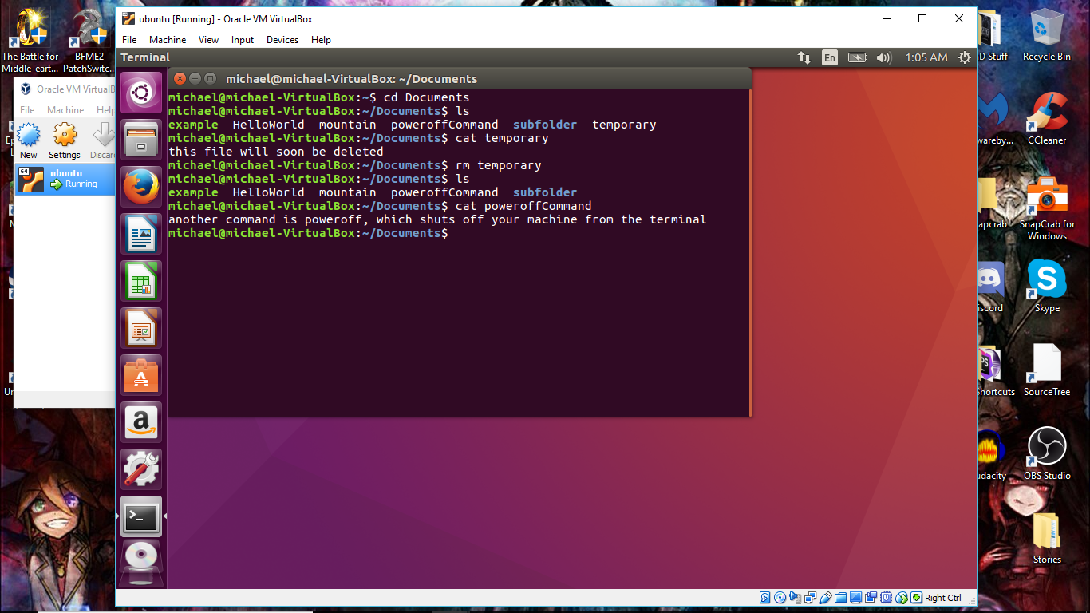

Shell Script test.sh

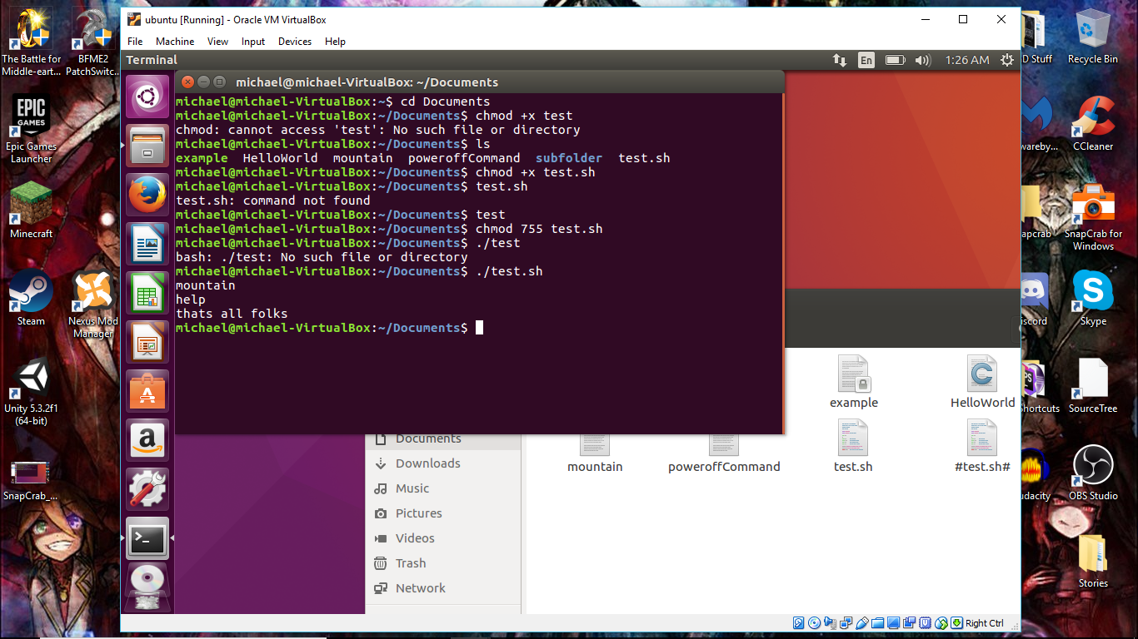

References

Shotts, William E. (2018). *Writing Your First Script And Getting It To Work*. Retrieved from <http://linuxcommand.org/lc3_wss0010.php>

Linuxandubuntu. (2016). *10 Basic Linux Commands That Every Linux Newbies Should Remember.* Retrieved from <http://www.linuxandubuntu.com/home/10-basic-linux-commands-that-every-linux-newbies-should-remember>

Seth. (2012). *How do I create a script file for terminal commands*? Retrieved from <https://askubuntu.com/questions/223691/how-do-i-create-a-script-file-for-terminal-commands/223698>